EXPT  NO:02 | EXPLORATORY DATA ANALYSIS (EDA) –  DATA IMPORT AND EXPORT

AIM:
To import the Space Mission dataset from various sources, perform basic exploratory data analysis using Pandas, and export the processed data into different file formats.
PROCEDURE:
- Open Jupyter Notebook and import the required libraries such as Pandas and SQLite3.
- Load the Space Mission Dataset (all_space_mission_launches.csv) using the read_csv() function.
- Display the first and last five records of the dataset using head() and tail().
- Examine the dataset structure using info(), shape, and dtypes.
- Generate a statistical summary using the describe() function.
- Identify missing values using the isnull().sum() function.
- Detect duplicate records using the duplicated() function and remove them if necessary.
- Save the dataset as an Excel file using the to_excel() function and verify it by importing it again with read_excel().
- Create an SQLite database and store the dataset as a table using the to_sql() function.
- Export the processed dataset to CSV, Excel, and JSON formats using to_csv(), to_excel(), and to_json().
OUTPUT:
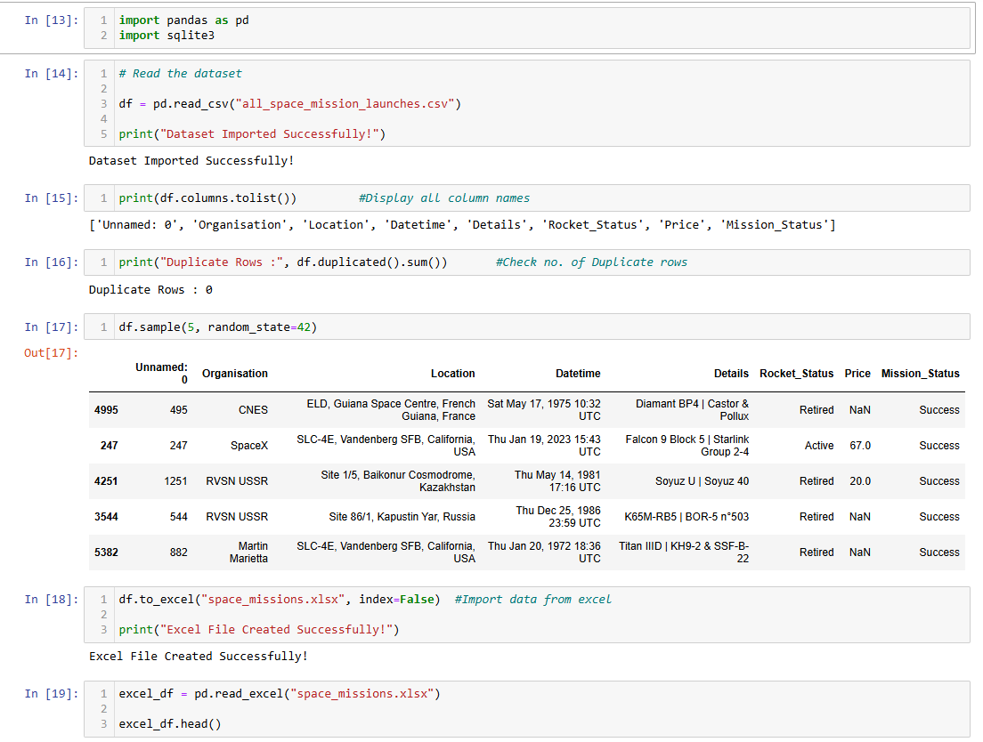
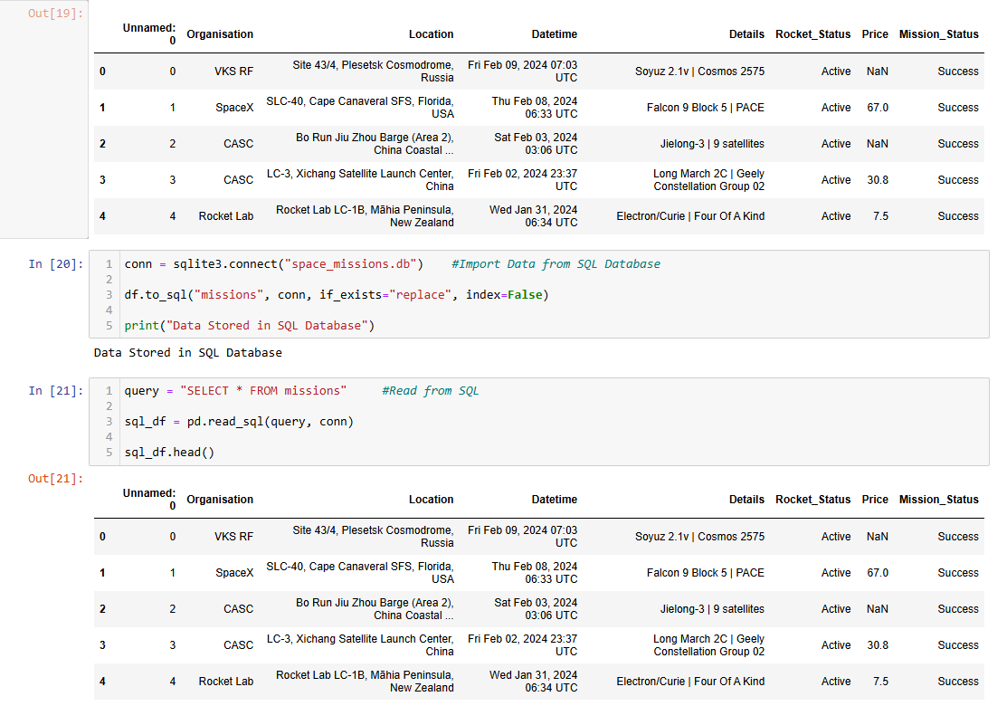
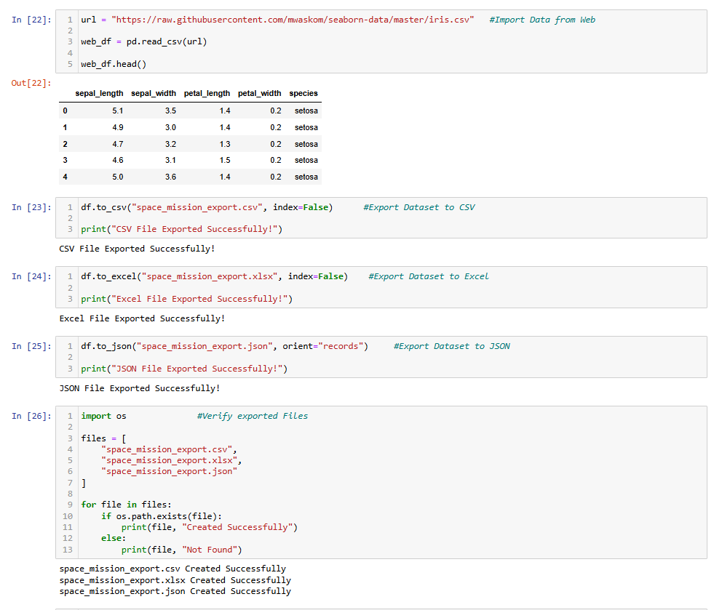
RESULT:
Thus, the Space Mission dataset was imported successfully, basic exploratory data analysis was performed using Pandas, and the processed data was exported into CSV, Excel, JSON and SQLite database formats successfully.

